**CSC 238 – Human Computer Interface Design**

California State University, Sacramento (CSUS)

Computer Science Department

Spring – 2024.

Team members: Aravind Yuvraj, Rajasekhar Reddy K, Kundana Bala Sai Sree L, Nithin G

**Assignment** – Heuristic Evaluation Response and Prototype Updates

**Team** – GraduGate

1. **Fixability Score:** 3 – Easy to fix.

**Before Fix:** Inconsistency in UI design not being standardized across the prototype like no back button in below example.

**After Fix:** We have added the back buttons to all the screens/across the prototype to make sure there is consistency in the UI design.

**Visual Changes and Explanation:**

**Before: After:**

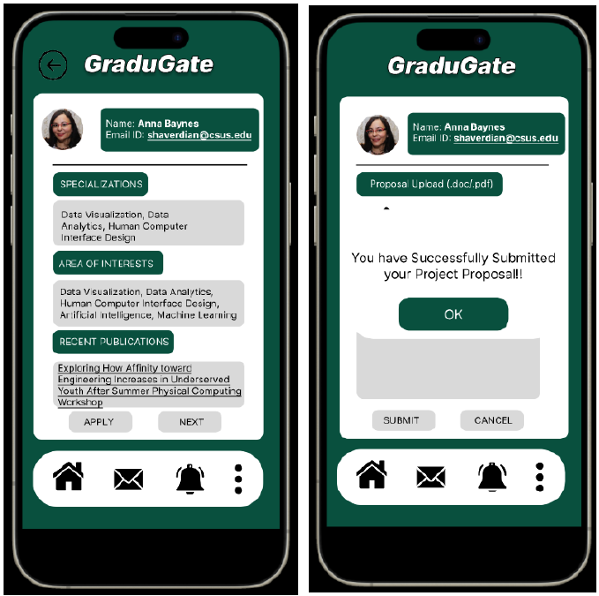 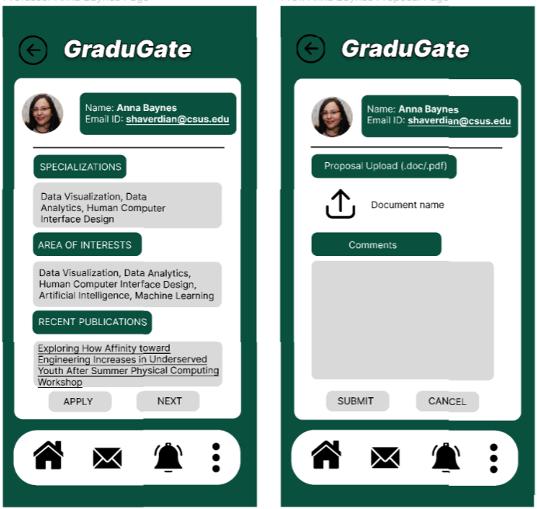

The addition of this button enhances user autonomy, allowing for quick navigation to previous screens without going back all the way to start page/home page. This reduces the friction in the user experience, adheres to the heuristic of user consistency and standards, and likely improves overall user satisfaction.

1. **Fixability Score:** 3 – Easy to Fix

**Before Fix:** Lack of confirmation dialogs or checks before performing irreversible actions as shown in below screenshot no confirmation before submitting.

**After Fix:** We fixed the issue by adding a prompt for confirmation before submission of critical information.

**Visual Changes and Explanation:**

**Before: After:**

 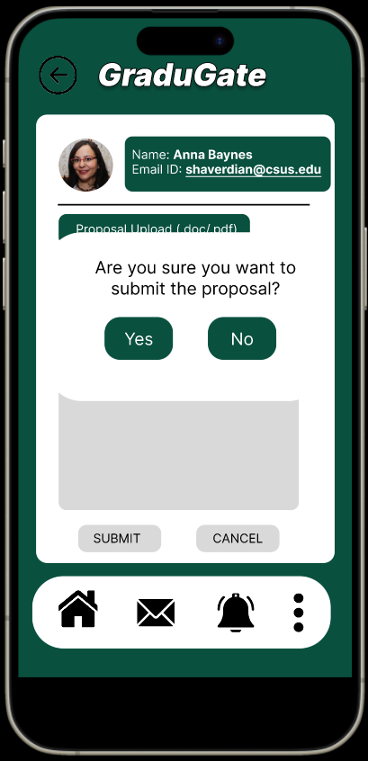

Before Fix, when the user clicks on Submit button, a pop-up screen will be appeared saying “You have successfully submitted your project proposal!!” without any confirmation dialog. We made a fix to make sure, it takes confirmation again from the user to make sure they want to submit the proposal or not. A pop-up screen with the message asking the user “Are you sure you want to submit the proposal?”. Now, if the user clicks on Submit, the proposal will be submitted and display the successful pop-up message.

1. **Fixability Score:** 3 – Easy to Fix

**Before Fix:** The system does not provide an efficient way for users to search for specific information or past entries, such as previously submitted proposals or faculty feedback.

**After Fix:** We made some changes to the student dashboard, where the user/student can now check their previous submissions to the professors.

**Visual Changes and Explanation:**

**Before: After:**

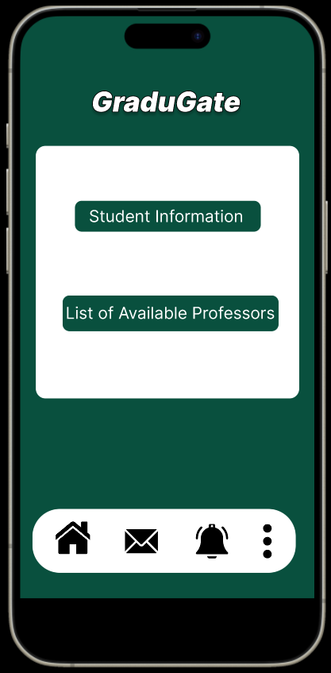 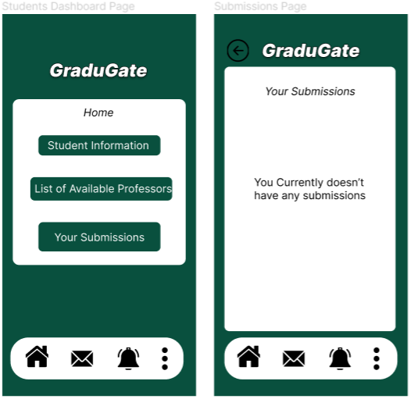

Before fix, the student dashboard just displays the student information and List of available professors for this semester. After fix, the new dashboard displays the student’s proposal submissions to the professors, where it navigates to a new page and displays the proposals submitted by the students as shown above.

1. **Fixability Score: 2 –** Difficult to Fix

**Before Fix:** Displaying availability of professors for the following semesters will be a plus point. This way students don’t end up sending applications to professors who are already planning to leave the campus. This could lead to a student wasting his time for a response, all the while which could be used to work on something else.

**After Fix:** Added a new feature in the List of available professor’s screen where it displays the status of the professors as “available” or “not available”.

**Visual Changes and Explanation:**

**Before: After:**

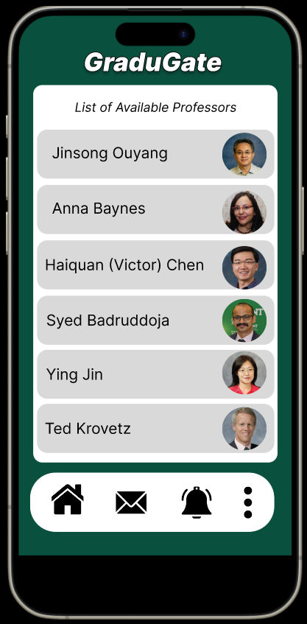 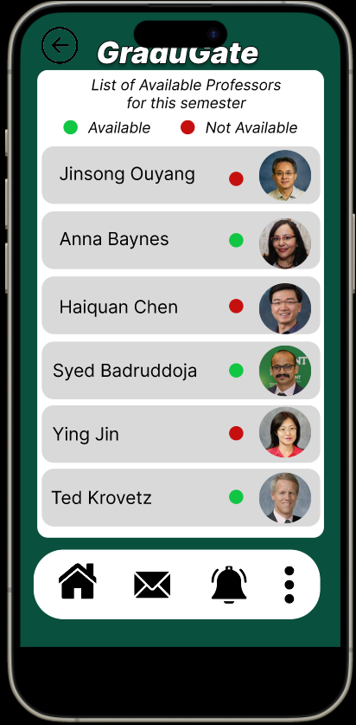

We made visual changes to the list of available professor’s page, where now it displays whether a professor is available to take/guide students for projects for the current semester or not. Further, the student can click on professor’s profile and see their interests and number of available spots left to work with them.

1. **Fixability Score:** 3 – Easy to Fix.

**Before Fix:** Users attempting to upload documents may encounter an error with no information on whether the issue is with the file format, file size, or an internal server error.

**After Fix:** We made changes to the upload documents screen, now displays the error message when an unsupported file is being uploaded by the user.

**Visual Changes and Explanation:**

**Before: After:**

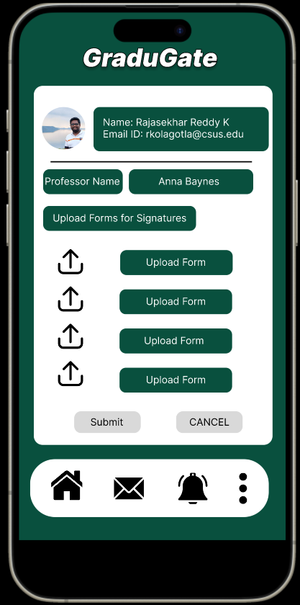 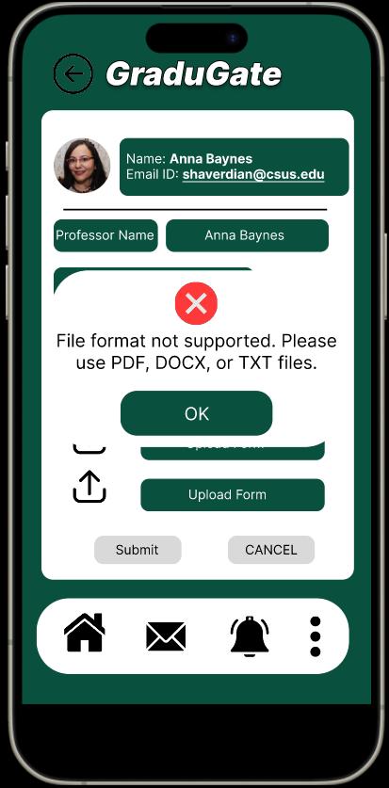

We added a new pop-up screen where it now displays a message “File format not supported. Please use PDF, DOCX, or TXT files.”, when user tried to upload unsupported file formats. This make sures only the correct format files are uploaded by the user.